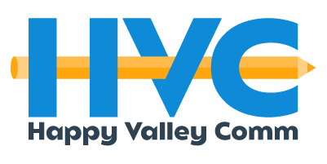

CLIENT HANDOVER BOOK
BY A THREAD BOUTIQUE
SPRING 2025
04/13/2025

Account Executive: Isabelle Flores
TIME PERIOD: January 2025 – April 2025
CLIENT CONTACT INFO
PROJECT STATUS
STATUS UPDATE
Instagram and TikTok feed are coming together nicely. With the incorporation of the photo and video content the team took, the compilation of content ideas, along with the use of the official branding (colors and typography), it will be fully cohesive. YouTube and Pinterest are kicking off and once the posting becomes more consistent using our list of content ideas and mood board inspiration, it should help the brand awareness.
CLIENT | By A Thread Boutique
PRIMARY CONTACT | Emily Boone
EMAIL | byathreadboutique@gmail.com
PHONE | (814) 599-8131

- KEY DATES AND MILESTONES
  - Use holidays calendar to track key dates
- PRIORITIES
  - TikTok
    - Leverage this platform to reach Gen Z (college students) audience
    - Post consistently
    - Pay attention to trends as they come up and follow them
    - Use trending sounds to get visibility
  - Pinterest
    - Leverage this platform to reach female audience
    - Create your own boards
    - Follow official branding to remain cohesiveness
  - YouTube
    - Leverage this platform to share more information and behind the scenes for all audiences
    - Long-form content
  - Outreach
    - Apartment buildings for pop-up shop events
    - Sororities for in-store candle making events
    - Influencers/content creators for PR mailers ultimately leading to UGC
- SPECIFIC INSTRUCTIONS
  - Use social media handbook to guide posting on socials
- RESOURCES AND TOOLS Information hubs:
  - Canva
    - Utilize templates the team put together to upload graphics with new drops/other featuring items
  - Capcut
    - Find current trends and easy-to-use templates for short-form video content
- DOCUMENTATION & ASSETS (Location of important files, assets, emails, etc.)
DOC/ASSET | FILE NAME | LOCATION/LINK
All Deliverables | By A Thread Boutique x HVC | Google Drive

